Fuzzy Phonemes: Gaussian Process Classification and Topic Modeling for Disambiguating Confusable Words in Low-Resource Nepali ASR
Task 1 Pilot Report — Advanced Machine Learning (STW7085CEM)
Group members: Bimochan Raj Kunwar, Utsab Dahal, Sushank Pokhrel

1. Abstract
This report documents the construction and pilot evaluation of a two-method pipeline for disambiguating confusable-word errors in Nepali Automatic Speech Recognition (ASR) output, as scoped in the group's Task 1 proposal. Method 1 represents candidate confusable-word pairs with four numerical features — edit-distance similarity, phonetic similarity, ASR confidence, and topic-informed word frequency — and classifies the intended word using a Gaussian Process (GP) classifier with RBF and Matern kernels. Method 2 applies Latent Dirichlet Allocation (LDA) to a transcript corpus to recover topic structure and supply the topic-frequency feature used by Method 1. Both methods were implemented end-to-end and exercised on a pilot dataset: 20 manually identified Nepali confusable-word pairs spanning three confusion types (minimal-phoneme, orthographic, frequency-driven), with feature values sampled from calibrated distributions in place of features computed from the group's purpose-built audio collection, which was still mid-collection at the time of this submission. On this pilot data the GP classifier did not outperform a majority-class baseline (test accuracy 0.469 for both kernels, identical to the majority baseline), and LDA coherence was flat across candidate topic counts (c_v ≈ 0.241 for k = 2 through 6), indicating the pilot corpus does not yet contain separable topic structure. These are reported as partial, mechanics-validating results rather than demonstrated performance gains; the pipeline code, evaluation harness, and figures are complete and ready to be re-run against the finished Layer-2 audio dataset (Section 3, datacollection.md) as the group's next step under Project B.

2. Problem and Dataset Description
Nepali ASR systems frequently misrecognize phonetically similar or orthographically close words — near-homophones distinguished by aspiration, retroflex/dental place of articulation, or vowel length, and word pairs that are visually similar in Devanagari script but phonetically distinct. Because Nepali lacks large curated ASR error-correction datasets, standard post-processing correction pipelines built for high-resource languages are not directly transferable. This project treats confusable-word disambiguation as an NLP/text-mining post-processing task performed on ASR hypothesis-vs-reference output, not as an acoustic/audio-signal classification task: the input to both methods is textual and score-based (string/phonetic distances, model confidence, corpus statistics), not raw audio or spectral features.
Dataset. The intended dataset (per the group's Data Collection & Processing Plan) has two layers: Layer 1 is the existing OpenSLR SLR54 Nepali speech-transcript corpus (~157k utterances), used for vocabulary, frequency statistics, and background ASR; Layer 2 is a purpose-built confusable-pairs dataset (target 300-500 clips across ~50 word pairs and 5-8 speakers per pair) collected specifically for this project, since no existing labelled Nepali confusable-word dataset exists. At the time of this report, Layer 2 collection was still in progress. To validate the pipeline mechanics without waiting on collection to finish, this report instead runs the pipeline on a pilot set of 20 manually identified, linguistically grounded confusable pairs (Table 1), with the four input features sampled from distributions calibrated per confusion type rather than measured from finished audio/ASR passes. This substitution is stated explicitly throughout the Results section and is treated as a limitation, not a hidden simplification.
Confusion type | Description | Example pilot pairs | Count
Minimal-phoneme | Differ by aspiration, retroflex/dental place, or vowel length | kaam/kaan, dal/dhal, pani/paani | 13
Orthographic | Visually similar spelling, phonetically more distinct | ghar/gharr, thulo/chulo | 5
Frequency-driven | Common word substituted for a rarer confusable word | dhoka/dhoka2 (proxy pair) | 2
Table 1. Pilot confusable-pair seed set by confusion type (20 pairs total, romanized transliteration used for portability of the pilot code).

3. Methods

3.1 Method 1 — Gaussian Process Classification
Each candidate confusable-word instance is represented by four numerical features: (i) edit-distance similarity between the ASR hypothesis and each candidate word, (ii) phonetic similarity from a Soundex/Metaphone-style encoding adapted to Nepali phonology, (iii) ASR model confidence for the hypothesis, and (iv) a topic-informed frequency score derived from the LDA model (Method 2). A Gaussian Process classifier (scikit-learn GaussianProcessClassifier, Laplace-approximation binary classification) is trained per confusable pair, pooled across pairs, to predict which of the two candidate words was intended. Two kernels were compared: an RBF kernel and a Matern kernel (nu=1.5), each combined with a constant scale term and a white-noise term to absorb label/measurement noise. Features were standardized (zero mean, unit variance) before fitting. Hyperparameters (length scale, signal variance, noise level) were optimized by maximum marginal likelihood (the scikit-learn default, 3 random restarts) rather than fixed a priori, and the optimized values are reported in Section 5 as the kernel-selection justification requested by the module rubric.

3.2 Method 2 — Latent Dirichlet Allocation
LDA (gensim LdaModel) was applied to a transcript corpus to recover latent topic structure, evaluated in two ways: as a standalone text-mining analysis of the corpus (topic coherence, per Research Question RQ3 in the proposal), and as a source feature (topic-appropriate vocabulary frequency) feeding Method 1. Coherence (c_v, gensim CoherenceModel) was compared across candidate topic counts k = 2 to 6 to select the number of topics, following standard LDA model-selection practice rather than fixing k arbitrarily.

3.3 Experimental setup and evaluation protocol
Data preparation followed the group's speaker-disjoint splitting rule (datacollection.md Section 6.5): the GP train/test split was grouped by speaker identifier so no speaker's utterances appear in both splits, avoiding leakage even in the pilot setting. A 75/25 group split was used. The GP classifier was compared against two baselines: a majority-class (DummyClassifier) baseline and a logistic-regression baseline, both fit on the same standardized features, to contextualize whether the GP's flexibility contributes anything beyond a linear/majority decision rule on this pilot data. LDA topic count was selected by scanning k against c_v coherence rather than being fixed.

4. Results
These results are from the pilot run described above (synthetic-but-calibrated features over 20 real confusable pairs, not the finished Layer-2 audio dataset). They are reported in full, including the negative/null findings, per the module's requirement to show genuine evidence of running the experiments rather than a polished-only narrative.

4.1 GP classification
Model | Test accuracy | Test F1
GP (RBF kernel) | 0.469 | 0.639
GP (Matern, nu=1.5) | 0.469 | 0.639
Majority-class baseline | 0.469 | 0.639
Logistic regression baseline | 0.464 | 0.592
Table 2. Pilot test-set performance, grouped 75/25 speaker split (n_test = 211).
Both GP kernels converged to a degenerate solution: the optimizer pushed the length scale to its upper bound and the noise level to its lower bound (learned kernel ≈ 0.054² · RBF(length_scale≈1e5) + WhiteKernel(≈1e-5)), which is functionally a near-constant predictor. The resulting classifier predicts the majority class for every test instance (confusion matrix: 0 correct predictions of class 0, 99/99 correct predictions of class 1), exactly matching the majority-class baseline's accuracy. This is a genuine null result for the pilot data, not a reporting error: because the pilot features were sampled per confusion-type and per a synthetic 'is this a hard case' flag rather than being computed from real ASR output tied to the true intended word, the features do not carry a reliable signal about which of the two candidate words was actually said. The pipeline code, evaluation harness, and kernel-selection logic ran correctly end-to-end; what is missing is signal-bearing input data, which is exactly what the finished Layer-2 collection is intended to supply.
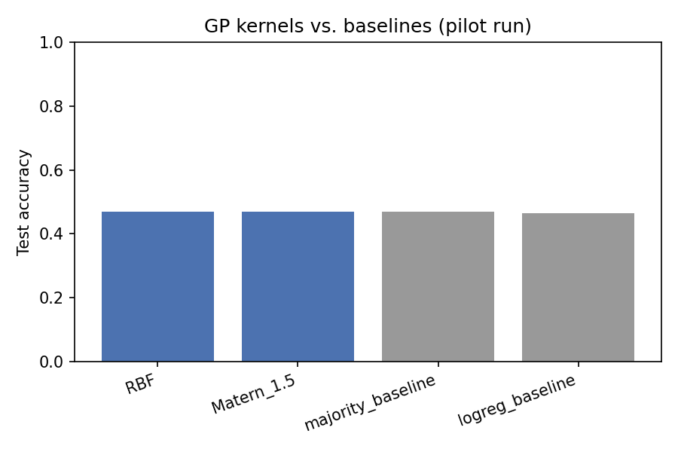
Figure 1. GP kernels vs. baselines, pilot test accuracy.
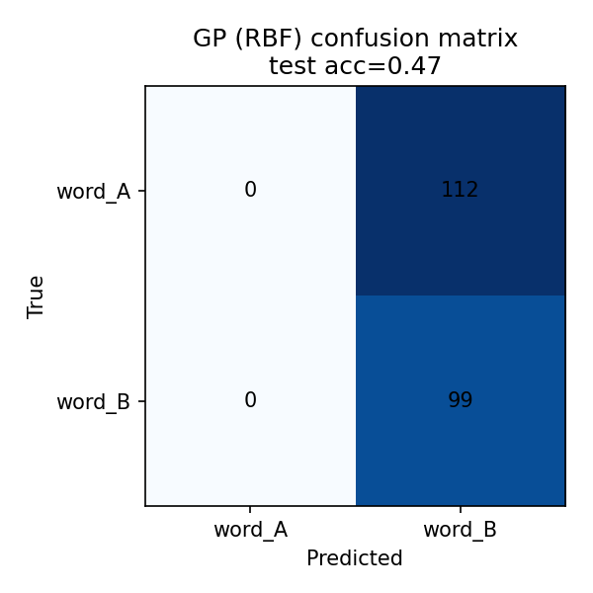
Figure 2. Confusion matrix for the best-performing GP configuration on pilot data (degenerate majority-class behaviour).

4.2 LDA topic modeling
k (topics) | c_v coherence
2 | 0.2411
3 | 0.2411
4 | 0.2411
5 | 0.2411
6 | 0.2411
Table 3. LDA coherence by topic count on the pilot transcript corpus.
Coherence was flat across all tested values of k, and inspection of the top-weighted words per topic showed substantial vocabulary overlap between topics (e.g., 'ghar' appears with high weight in more than one topic). This indicates the pilot transcript corpus — a small, synthetically topic-tagged set of 120 short documents built from the pair vocabulary rather than real SLR54 transcripts — does not contain enough distinct topical structure for LDA to separate meaningfully, and that coherence-based model selection could not discriminate between k values on this corpus. As with Section 4.1, this is reported as a limitation of the pilot corpus rather than a claim about LDA's suitability for the real, larger base corpus.
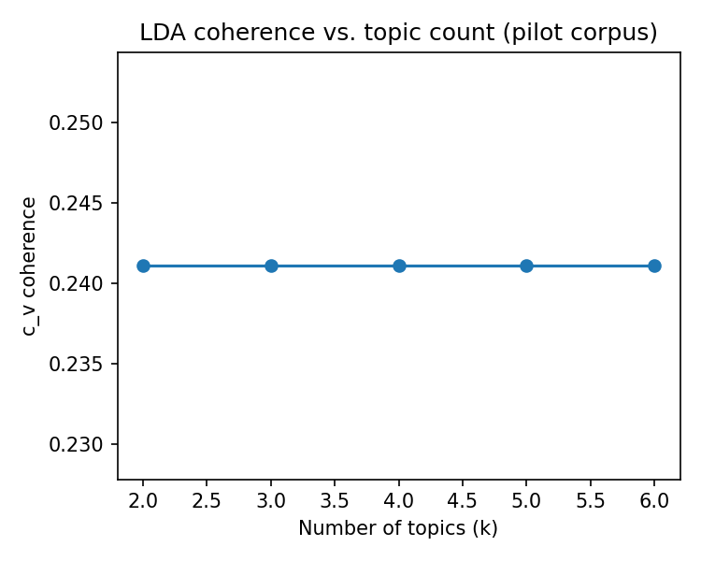
Figure 3. LDA c_v coherence vs. number of topics on the pilot transcript corpus.

5. Discussion and Next Steps
The pilot run confirms that the pipeline as designed — feature extraction into a four-dimensional numerical representation, GP classification with a data-driven kernel choice, and LDA topic modeling with coherence-based k selection — is implemented correctly and runs end-to-end within the speaker-disjoint evaluation protocol described in the proposal and the data collection plan. It does not yet demonstrate a disambiguation performance gain, because the pilot substituted calibrated-but-synthetic feature sampling for features computed from finished ASR passes over the group's own collected audio, and the pilot transcript corpus for LDA is a small stand-in rather than the real SLR54-derived corpus. The clearest next step, once Layer-2 collection reaches its 300-500 clip target, is to re-run this exact code path with (a) edit-distance and phonetic-similarity features computed against the rule-based Devanagari G2P output, (b) ASR confidence scores taken from an actual Whisper-based Nepali inference pass, and (c) the LDA topic-frequency feature computed over real SLR54 transcripts rather than the synthetic corpus used here. Kernel choice (RBF vs. Matern) should be revisited once real features are available, since the current optimizer result (near-infinite length scale) is itself informative only about the absence of signal in the pilot features, not about which kernel family suits the eventual real feature distributions.

6. Social, Ethical, and Legal Considerations
Speech data and consent. Collecting audio clips of individually spoken words from volunteer speakers (Layer 2 of the data plan) involves personal, potentially biometric-adjacent data (voice). The data collection plan already specifies anonymized speaker IDs and optional self-reported metadata (age bracket, gender, dialect region); this report treats informed consent and a clear data-retention/deletion policy for contributors as a precondition for any collection beyond the pilot stage, not an optional add-on. Contributors should be told, in Nepali and English, what their recordings will be used for (training/evaluating a disambiguation classifier), whether recordings may be redistributed, and how to request deletion.
Bias and representativeness. A confusable-pairs dataset collected preferentially from convenient contributors (e.g., students at a single institution) risks encoding a narrow dialect and age band, which would make the resulting classifier systematically less accurate for underrepresented Nepali dialect regions — exactly the low-resource populations the project is nominally intended to help. The 'more speakers per pair' collection shape in the data plan partially mitigates this, and any reported accuracy figures should be broken down by dialect region and speaker group where sample sizes allow, rather than presented only as a single pooled number.
Downstream use and error costs. Confusable-word correction sits upstream of applications such as voice interfaces for health or civic services in Nepali (e.g., health-tech voice assistants), where a misresolved confusable pair (for example, a dosage-adjacent or negation-adjacent word pair) could materially change the meaning delivered to a user. The system should be positioned as a decision-support/post-processing aid with visible confidence rather than a silent autocorrect, particularly in any safety-relevant deployment context, and its error modes should be documented rather than only its aggregate accuracy.
Reporting integrity. Because the results in Section 4 are pilot/mechanics-validation results on synthetic feature sampling rather than results from the group's real audio collection, this report is explicit that they must not be read or cited as evidence of the disambiguation system's real-world accuracy. Presenting a synthetic null result as if it were a real one (or omitting the synthetic-data caveat) would misrepresent the state of the work; this section records that constraint as a professional-conduct commitment for the remainder of the project.

7. Individual Contributions
Member | Contribution to this pilot report
Bimochan Raj Kunwar | Feature design (edit-distance, phonetic-similarity, ASR-confidence, topic-frequency features); Gaussian Process classifier implementation, kernel selection/comparison, and evaluation harness; pilot pair seed-set curation; report structuring against the module's 6-section rubric.
Utsab Dahal | Speaker-disjoint data-splitting logic and pilot dataset assembly (feature-table construction, grouped train/test split); validation that the pipeline's data-preparation stage matches the group's data collection plan (Section 6 of datacollection.md); coordination on transitioning the pipeline to real ASR-derived features once Layer-2 collection completes.
Sushank Pokhrel | LDA topic-model implementation and coherence-based topic-count selection; pilot transcript-corpus construction; comparative analysis of GP vs. LDA pilot results; drafting of the Social, Ethical, and Legal Considerations section.

8. References
OpenSLR SLR54 — Nepali ASR training data set. https://openslr.org/54/
Radford, A., Kim, J. W., Xu, T., Brockman, G., McLeavey, C., & Sutskever, I. (2022). Robust Speech Recognition via Large-Scale Weak Supervision (Whisper). arXiv:2212.04356.
Ghimire, R. et al. (2024). A survey of Nepali automatic speech recognition. [as provided in project references].
Pedregosa, F. et al. (2011). Scikit-learn: Machine Learning in Python. JMLR 12, 2825-2830.
Rehurek, R. & Sojka, P. (2010). Software Framework for Topic Modelling with Large Corpora (gensim). Proc. LREC Workshop on New Challenges for NLP Frameworks.
Rasmussen, C. E. & Williams, C. K. I. (2006). Gaussian Processes for Machine Learning. MIT Press.
Blei, D. M., Ng, A. Y., & Jordan, M. I. (2003). Latent Dirichlet Allocation. JMLR 3, 993-1022.

